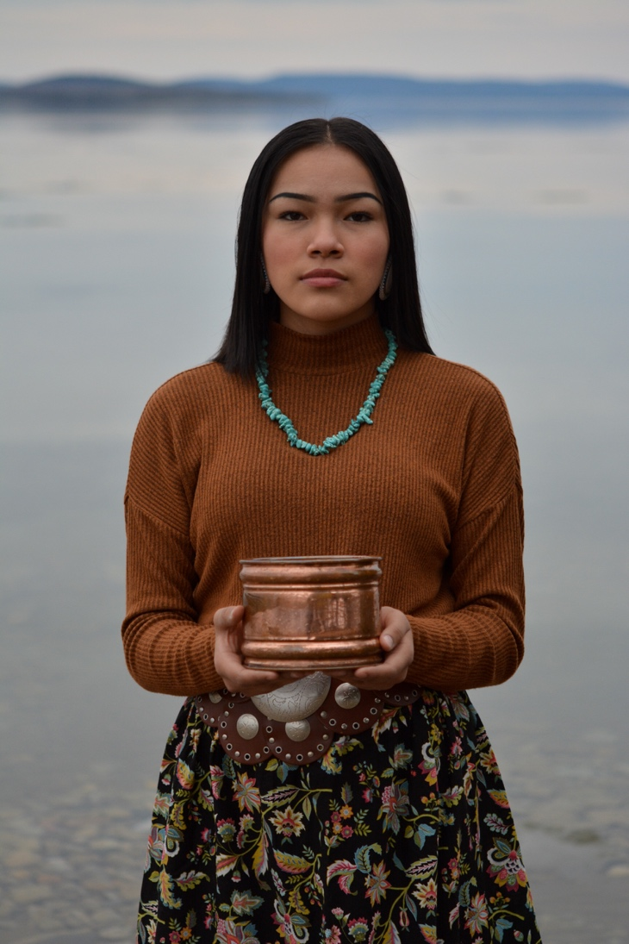
Autumn Peltier: The Girl fighting for Cleaner Water
By Lucy Garrett

Autumn Peltier is a 15-year-old girl who is a member of the Wiikwemkoong First Nation. She is an advocate for clean water. An advocate is a person who speaks up to support or defend something or someone. She speaks up to people to make sure that everyone has access to clean water that they can drink. Autumn was born on September 27, 2004. She lives in Ottawa now where she has been attending high school.

Autumn has always known that water needs to be protected. From the age of 8, she has been attending First Nation water ceremonies. She wants everyone to be able to have clean water. She has spoken at several meetings and has traveled all over the world to speak at different places.

She was named the Chief Water Commissioner by the Anishinabek Nation which means that she is a part of a group of people from 40 different First Nations who speak up for what they believe in. Her role model is her aunt whose name was Josephine Mandamin. Josephine was the Chief Water Commissioner before Autumn and she encouraged Autumn to never stop speaking up for clean water. She is also known as the “Water Warrior” because of her work and how she defends people’s rights to access to water.

Autumn is known around the world and she has spoken to people in the government about clean water. She is someone that many people and many children look up to. She wants to encourage other people to stand up and speak up so that people who do not have clean drinking water can have water that they can use.

References:
https://www.cbc.ca/news/canada/sudbury/autumn-peltier-chief-water-commissioner-1.5111137

https://en.wikipedia.org/wiki/Autumn_Peltier

Photo Courtesy of: https://www.womenofinfluence.ca/category/rise-of-girls/, Retrieved on April 21, 2020

