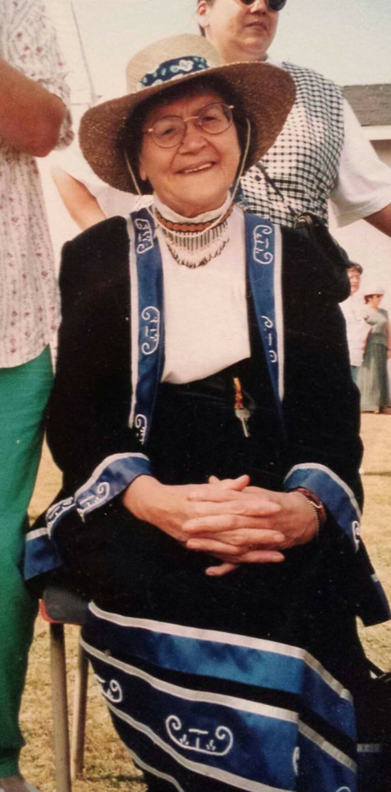
Rita Joe: A Mi’kmaq Poet and Writer

By Lucy Garrett

Rita Joe was a Mi’kmaq poet and writer from Cape Breton Island in Nova Scotia. She is known for her poetry and writing that talked about Indigenous identity and the experiences that many Indigenous children had at residential schools. Rita was born on March 15, 1932 in Whycocomagh, Nova Scotia. Her parents were called Joseph and Annie Bernard. They lived on a reserve in Cape Breton. Sadly, when she was 5 years old, her mother passed away and she was sent to live with a foster family. When she was 9 years old, she went to live with her father and 4 siblings for a year. It was then that her father died and she was sent to another foster family. Rita entered the Shubenacadie Indian Residential School in Nova Scotia where she was not allowed to speak her language (Mi’kmaq) and she had to work very hard.

When she was done school, she worked at several different places before she moved to Boston in the United States. While living there, she met her husband, Frank Joe, who was also originally from Nova Scotia and was from Eskasoni, a Mi’kmaq First Nation that was near where she had grown up. The two of them ended up moving to Eskasoni where they raised 10 children.

Rita wrote many poems and published several books. Her first series of poems was sent out to people in 1978 and then her second in 1988. It was in this series that her most well-known poem (“I Lost My Talk”) was published. Rita wanted people to hear her story and give other people a chance to learn about the Mi’kmaq people from a Mi’kmaq person. So when she wrote, she always kept that in mind as her goal. She released her third book in 1991 and a memoir of her was made in 1996. It was in this memoir that she wrote more about her story, the difficulties she had to face and the amazing things she had done in her life.

Rita won several awards for her writing and she was appointed to be an Order of Canada, which is a medal given to people who did incredible work in their community and served their nation well.

Rita helped her community and society by sharing her Indigenous voice with other people, both Indigenous and non-Indigenous. She spoke out about the truth of the bad things that happened in the residential schools, but also spoke a lot about the healing and reconciliation process. She influenced both Indigenous and non-Indigenous people with her words. She died on March 20, 2007.

References:
https://www.thecanadianencyclopedia.ca/en/article/rita-joe

Photo Courtesy of: https://siwarmayu.com/selected-poems-from-we-are-the-dreamers-recent-and-early-poetry-by-rita-joe/, Retrieved April 19, 2020

