Terry Fox: An Athlete and an Inspiration
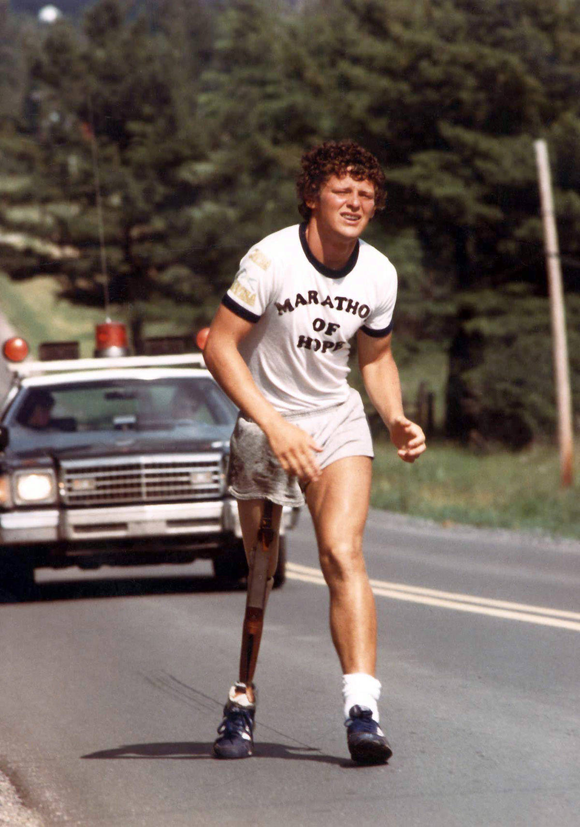
by: Lucy Garrett

Terry Fox was an athlete whose brave fight against Canada is remembered by many Canadians. Terry Fox was born on July 28, 1958 in Winnipeg, Manitoba. He had 3 brothers and 1 sister. His parents, Betty and Rolly Fox met in Winnipeg. Rolly Fox, his father, worked for the Canadian National Railway. In 1966, the family moved to British Columbia because they were tired of the cold winters in Manitoba. Growing up, Terry loved to play basketball and he never gave up on his dreams to play the sport he loved. He worked very hard and practiced a lot to get good at the sport. When he was in university, he played for his school’s team! He also liked to run and play rugby. When he was in Grade 12, he won his school’s Athlete of the Year Award because he played sports so well.
When he was in university, his knee started to hurt a lot. He was in a lot of pain so he went to see a doctor. It turned out that he had a serious sickness in his knee, a type of bone cancer. Since the sickness could spread to the rest of his body quickly, the doctors decided that the best treatment for it was to amputate his right leg and then give him a special kind of medicine for the sickness. Amputate means to remove the sick part of the leg so that the rest of the body can stay healthy. But that did not stop him from playing basketball! In 1977, Terry was asked to play on a wheelchair basketball team. He even got to go to Edmonton to play in a big tournament.
Terry had something else he wanted to do. While he was sick in the hospital, he had witnessed many other people in pain because of the sickness. He decided that he was going to run across Canada to raise money and awareness for doctors and scientists to find better medicine for cancer. To do this, he had to train and practice running. It would be a long way to run and he wanted to be prepared. He even had a special leg made to replace the missing one.
In April 1980, after writing some letters and gathering support from people, Terry began his run across Canada. He called it his “Marathon of Hope.” He started in St. John’s Newfoundland. Each day he would run about 42 km. He ran through Nova Scotia, New Brunswick, Prince Edward Island, Quebec and Ontario. By the time he got to Ontario, he was a national star! Everyone had heard of Terry and his “Marathon of Hope.” He even got to meet the prime minister and some NHL hockey players!
On September 1, 1980, he was in Thunder Bay, Ontario and sadly, he had to stop running because his sickness had gone to his lungs and he could not run anymore. Terry ran for 143 days. By this point, he had run 5,373 km!
Because he got sick again, Terry was unable to finish his marathon. He went to a hospital in British Columbia where he died on June 28, 1981. He was not forgotten though. People have continued to collect money and many schools across Canada do a “Terry Fox Run” to remember him and all that he did to collect money and help people who are sick like him. There are also statues of him in several places in Canada.

References:
https://www.thecanadianencyclopedia.ca/en/article/terry-fox

Photo Courtesy of: https://www.mapleridgenews.com/news/foxforfiver-support-grows-in-b-c-to-put-terry-fox-on-new-5-bill/, Retrieved on April 20, 2020

